HEATED GRIPS & DELUXE THUMB WARMER

THUMB WARMER INSTALLATION INSTRUCTIONS:
1) Clean the throttle of any dirt or grease and remove the release paper from warmer and press it where the thumb rest on the throttle. NOTE: Rubber cover on metal throttle lever should not be removed.
2) Slide the shrink tube over the end of throttle so it covers the thumb warmer and use the heat gun to shrink the tube.NOTE: Heat evenly around tube. (Do not burn the tubing)
3) Find a convenient location for the switch and make sure there is enough clearance for the electrical connections.
Drill a 13/16" switch hole and install the switch then route the heater wires along the handlebar and secure them with cable ties. NOTE: The wires in the throttle area cannot be too loose or too tight.
CAUTION: Ensure there is no binding when operating the throttle and that there is enough wire available when throttle is fully open.

Connect electrical wires using diagram below.
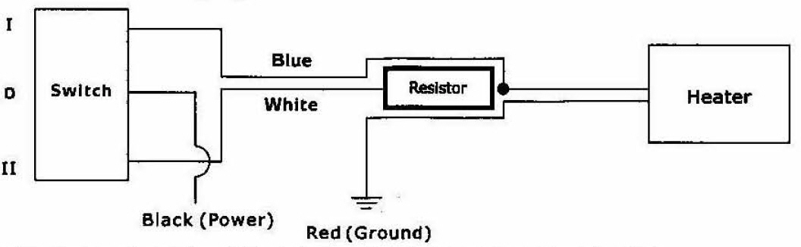
4) Locate any power wire on the vehicle and connect black wire using the piggyback terminal. NOTE: The most common location to find power wire is behind ignition key.
WARNING: Insulate this wire connection from any possible grounding. This must be switched power circuit. If not, thumb warmer may overheat and fail or drain your battery.
5) Locate any ground wire and use piggyback terminal on the thumb warmer red wire to make connection.
NOTE: If no ground wire is available, connect wire to the frame as a ground.

Use caution when operating the warmer for extended periods.
Do not cut or needlessly flex the heating element

ADHESIVE HEATED GRIPS INSTALLATION INSTRUCTIONS:
1) Remove grips. If you have rubber grips, heat them until they become flexible. Break the mastic by inserting a Philips screw driver between grip and handlebar, then pry grip straight off. CAUTION: Don’t attempt to twist off grip.
2) Remove all residue (glue, rubber... etc) from area covered by grip on handlebar. Use a glue remover and if necessary a fine sandpaper. WARNING: The surface must be residue free and dry before proceeding.
3) Remove white contact protector from heating element and encircle cleaned area with heating element.
4) Replace rubber grips on each side.
5) Attach wires along control wires to pass underneath the hood.
6) Drill a 13/16- hole in dashboard for installation of the HI-OFF-LO switch.

Connect electrical wires using diagram below.
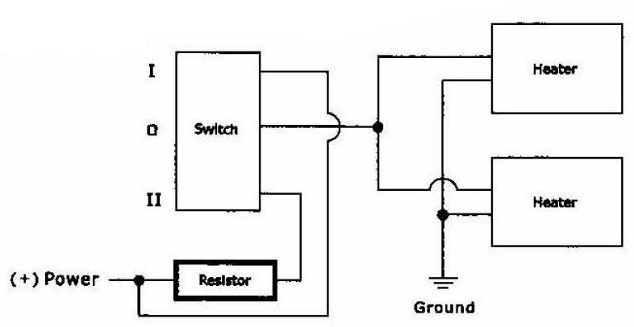

DISCLAIMER: This kit and electronic items in general are sold without any expressed or implied warranty of merchantability or fitness for a particular purpose. The Manufacturer, Distributor, nor Dealer shall be held liable for any special, incidental, or consequential damages, including damage, loss of revenue, cost purchased or use of this product.

